Longines - 5 Star Admiral, Super Looking and Near Mint Condition with a Jet Black Dial with an Inset Diamond, 10K Gold Filled Square Cut Corner Case with a 17 Jewel Automatic Movement.
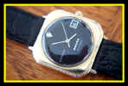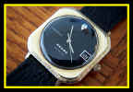
Description/Comments:
Here is a beautiful 1960s Automatic 17 Jewels Longines wristwatch in near mint condition. It features a 10K yellow gold filled square cut corners case with a round jet black dial which has an inset diamond at the 12 o'clock position. This beautiful watch just yells out class and is keeping good time.
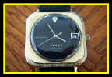
Case:
The case measures 1 3/8" (including the crown) and 1 1/2" (lug-to-lug), and it is 5/16" thick. The back of the gold case is marked 10K Gold Filled and Use 1100 Wrench. The bezel features a notched edge all around the case which is finished with fine textured lines which accent the smooth finished surface of the rest of the case design very nicely. The original gold crown is located at the 3 o'clock position.
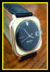
Dial:
The round dial has a gorgeous jet black background and silver markings and is in near mint condition. The thin and stylish index-style hour, minute and sweep seconds hands are silver. It is signed Longines at the 9 o'clock position, and Admiral with 5 stars above the 6 o'clock position. The date window is located at the 3 o'clock position. A diamond is inset into a triangular shaped marker at the 12 o'clock position. The round crystal is flat on the surface with curved edges and is raised 3mm above the bezel.
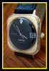
Band:
A brand new high quality Speidel Express 18mm genuine leather that is black colored with sewn edges and a crocodile textured finish. It has a yellow gold toned buckle which perfectly matches the watch.
Movement:
A high quality Longines Automatic movement marked Longines Watch Co., Swiss, and Seventeen 17 Jewels. The watch is running strong and keeping good time.

