CLOCK AND WATCH ESCAPEMENTS
centres is usually as in the recoil, the radius of the wheel multiplied by 1 -4. This, of course, varies with different escapements, depending on the number of teeth of the wheel and the number of teeth spanned by the pallets.
In quite a number of Continental clocks of high quality and usually in astronomical clocks which have a seconds hand and a half-seconds pendulum there is a dead-beat escapement with a 'scape wheel of 60 teeth. Often these have pallets which span 20 or even more teeth.
It is not often one meets a clock with a seconds pendulum where the pallets span 14 teeth of a wheel of 30, but they have been made; the performance, however, cannot be compared with an escapement where only 8 or 10 teeth are spanned.
To Draw the Escapement
There are various ways of drawing the dead-beat escapement, and an attempt will be made to describe it in such a way that its actions can be easily understood (Figure 33).
First a circle is scribed representing the full diameter of the wheel A_{x}. The diameter is drawn through the centre and extended by a little more than the radius beyond the circle A₂. On this line is planted the pallet centre or what would be the pallet-arbor hole B. For convenience the wheel will have 30 teeth; whilst the pallets will span 8 teeth and be spanned by 9 teeth, i.e. 9 teeth outside the pallets and 8 teeth inside. The centre of the pallet faces will be on a line 45° from the centre line.
These two lines are now drawn one on each side of the centre line and long enough to cross the circumference C_{x} and C₂. The point where these lines meet the circumference will be the centre of the pallet faces D_{l5} D₂. Tangents are now drawn from these points to pass through the centre line E_{1}} E₂, and if correctly drawn the two tangents will meet at precisely the same point B, which will be the pallet-arbor hole and pallet centre.
There is a 12° space between 2 teeth which is the total width of the two pallet faces plus drop and the thickness of the tip of each tooth. This means \° drop, which on an inch-diameter wheel is 0-004 in., with the same amount for the tip of the tooth. These figures are for a very accurate wheel and pallets, but for the ordinary dead-beat and for the purpose of the drawing 1 ° is allowed for each. This will leave 10° for the total thickness of both pallets or 5° each, which is, of course, the width of the impulse planes.
V£ is now marked off each side of the 45° line on the left side F_{l5} C₂.
The impulse in a dead-beat is usually 2°, but it is not imperative from a practical point of view; however, if a really close rate is wanted 2° has been proved to be the best, so 3° is marked off below line E_{v} This includes 1° locking or rest as well as the 2° impulse. The locking face of the entrance or first pallet G_{x} is found by joining
46
THE DEAD-BEAT ESCAPEMENT
up the line on the far left, i.e. the line 2\° F_{x} anti-clockwise of the 45° line, to the pallet centre.
A circle is drawn using the pallet centre as centre and the locking face as the point in the circumference. This will give both the locking face of the entrance pallet and the outside circle of the exit pallet
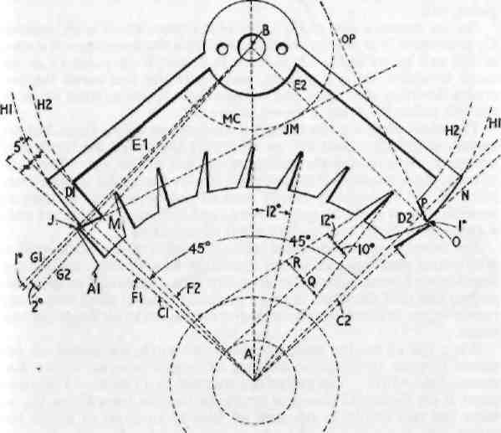
Figure 33. Theoretical drawing of Graham dead-beat escapement in which the pallets span 8 teeth and are spanned by 9. This is the recognised
standard type.
or dropping-off corner H_{v} 1° is now marked off from the pallet centre on line G_{x} towards the wheel and a line drawn crossing the circumference and meeting the circle of the pallet faces. This represents 1° locking or rest, G₂. In a very accurate escapement this can be reduced \°. This point is where the impulse plane commences, J.
2° is marked off from line G, again towards the wheel and a line drawn to cut the circumference of the wheel. This is the angle of impulse or the amount the pallet moves or is lifted.
47
CLOCK AND WATCH ESCAPEMENTS
From the centre of the wheel a line is drawn which is 5° to line G, and which will cross the circumference This line gives the width of the pallet face, and where it meets G_{x} is the dropping-off corner, M. The points J and M are now joined and extended to the centre JM. The compasses are set at the pallet-arbor centre and opened to meet point M, and a circle is scribed which will give the inside faces of both pallets or nibs, M₂. Another circle is scribed to which the line JM is a tangent. This will decide the impulse plane of the exit pallet, MC.
On the opposite side at C₂ a line N is drawn which is 2^° outside C₂ and where N is met by the circle will give the dropping-off corner of the exit pallet H^O. A tangent is drawn from point O to the circle to which JM is a tangent, and where this line meets the two circles denoting the inside and outside faces is the impulse plane of the exit pallet, P. This is shown as line OP.
The wheel teeth are not radial on the front or acting faces, but are under cut usually about 10° so that only the tip of the tooth is in action Q, this ensuring the minimum amount of friction. The back of the tooth is usually 12° to the front, but for strength it is sometimes more, R. The wheel is usually crossed out to make it as light as possible, but it must be quite strong, and although sometimes only 4 arms are left, the best quality often have 6 arms.
The wheel is usually screwed on to the collet of the 'scape-pinion arbor, thus guarding against the distortion which often occurs if the wheel is not riveted to its collet very carefully. It should be unnecessary to add that the wheel must be perfectly flat and dead true if any rate is to be obtained, for any lack of truth means extra freedoms and losses.
When setting out the escapement in cases where the pallets are designed to span 10 teeth the distance of centres is equal to the diameter of the wheel. The pallets are spanned by 11 teeth. Therefore point B on Figure 34 does not apply, neither do lines C_{x} or C₂, as these last two would be replaced by lines at an angle of 57° to the central line, but otherwise the set-out is the same. Thus the distance of centre and lines C₁ and C₂ varies according to the number of teeth spanning the pallets.
It will be noticed how the angles of impulse are raised as the number of teeth spanned are increased, although the amount of lift is the same. The arms of the pallets are also increased in length, and one naturally assumes that less power is required to move the pallets as the arms lengthen; this is so, but as the length of the impulse planes is longer, the friction is increased.
The changing oil, due to temperature changes, affects the rate of the dead-beat escapement to a great extent, and thus one has to consider the amount of time that the impulse planes are engaged, although the engagement takes only a second in each case. To put it plainly, the speed of the tooth is greater where the impulse plane is longer and is more easily affected by changing oil.
48
THE DEAD-BEAT ESCAPEMENT
Oil, which is, of course, essential, becomes thinner in a higher temperature and thicker in a lower temperature, whilst there is also the adhesive friction, which is more exaggerated the longer the parts are in action. The aim therefore must be to reduce the extent to
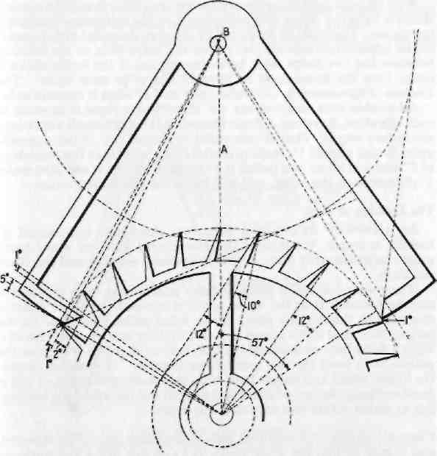
Figure 34. Dead-beat escapement. In this the distance of centres is
greater and there are higher impulse angles. The pallets span 9 teeth and
are spanned by 10.
which surfaces are in action, and this is the reason why the escapements with pallets spanning or embracing 8 teeth are preferable to ones spanning a higher number.
Inside and Outside Shake or Freedoms
All escapements suffer more or less from wear and have to be repaired, holes or bearings which support the pivots of the pallets and 'scape pinion becoming worn and having to be renewed. When
49

CLOCK AND WATCH ESCAPEMENTS
THE DEAD-BEAT ESCAPEMENT

replacing holes great care must be taken to avoid drifting from the original position, for if any drift does take place the inside and outside shake suffer or the drops become unequal, and one or the other may become too close, with the result that the 'scape wheel cannot pass.
With all dead-beat escapements the golden rule is that if the outside shake is tight the 'scape and pallet depth or the distance of centres is too close. This must be corrected by drawing the pallet hole or bearing an appropriate amount away from the 'scape hole, or the distance between the two holes must be increased, but if the inside shake is close, then the holes must be brought nearer to each other. The amount of movement is, of course, only half of what it appears to be.
All double-beat escapements, i.e. those where there is impulse to each vibration, have one definite factor, and this is that all alterations act in two ways. Thus if one pallet is altered say 1 ° the opposite pallet is also altered 1°, making a total of 2°, so if there is a total drop of 2° and it is all on one pallet, if 1° is taken off one it will also make 1° difference to the other, and will bring the two pallets equal.
The Locking or Rest
As previously stated, in a first-class dead-beat escapement \° locking is ample, but it must be remembered that the wheel tooth must unquestionably lock, or the escapement will fail and the clock will stop.
When wear has taken place and the pallets have been repaired it may be found that as the wheel tooth is released from one pallet it drops on to the impulse plane of the other pallet instead of on the locking face, and if this occurs it is said that the escapement mislocks. With a dead-beat escapement the only way to alter this is to close the pallets or to bend the two arms closer together. Unless, of course, the 'scape wheel and pallets have been very badly planted, and this is most unlikely, the fact of altering the depth will not affect the locking, but as stated earlier will only alter the drops.
Unequal Lockings—Sometimes pallets are badly treated or repaired, and it may be that the wheel tooth locks on one pallet and mislocks on the other. This means that the impulse planes are at different angles or that one is shorter than the other.
If the former is the case the only way to correct it is to make the impulse planes the same. This would mean that they would then both mislock, and it would also entail closing the arms to make the locking correct. If, on the other hand, the latter is the case it may mean that a new pair of pallets will be needed. If, however, only one pallet is bad and the other is in good order a new pallet can be put on the faulty side.
Fitting a New Pallet—This is done by cutting away the pallet and part of the arm, and filing the arm to half its thickness for a short
50
distance, sufficient to be quite sound. A piece of steel is fitted to this and filed so that the new piece and the remaining half of the arm combined equal the thickness of the original. The two pieces are fitted together and two suitable holes drilled through both of them while they are clamped in this position. They are then riveted firmly together as though solid. Next the new pallet-to-be is marked off with a pair of dividers, using the other pad as a guide.
The width of the impulse planes can easily be marked off with the
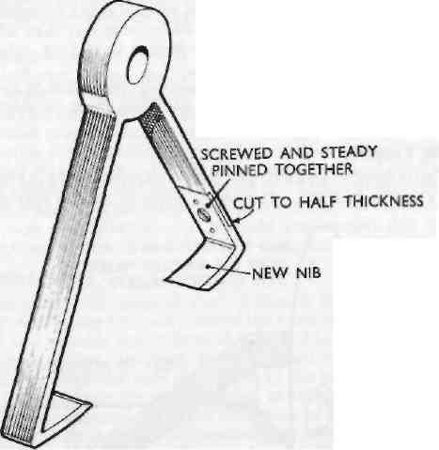
Figure 35. Fitting a new nib or part of a pallet and arm is often quicker than making a new pair complete.
dividers, but the angle of impulse is not quite so simple, and in a repair job this can be arrived at only by trial. First, a flat lace is filed as near to the angle as possible and then the pallets are put in the frame with the 'scape wheel and the angle altered until the locking is equal on both pallets. If when the lockings are equal they are too deep the impulse plane can be filed back, carefully preserving the angle until the lockings are correct, but it must not be forgotten that the amount which is filed away is only half of what might be cxDcctcd.
Continental clocks are often provided with a turntable on the front plate, the turntable having the pallet-arbor pivot hole planted eccentrically in the table. Thus the depth of the escapement is easily
51

CLOCK AND WATCH ESCAPEMENTS
adjusted and the inside and outside shake made perfect, but as previously stated this will not correct the locking.
Polishing the Pallets—Dead-beat pallet faces are best polished on a lap so that they can be kept perfectly flat. For this purpose a polishing lap made from zinc or from vegetable ivory can be used, the latter being the hardened or dried kernel of the coconut, and it is better than elephant ivory for polishing. The ivory gives a better polish than zinc and is also quicker, but it must revolve at high speed, and the work must be kept moving, otherwise the surface becomes ridgy. Diamantine, which is purchased mixed with oil at the material dealers, is used on the lap, but the mixture must be more oily than when used for other polishing. It must be well beaten in mixing, otherwise it will scratch.
Diamantine cuts or grinds when wettish, but polishes as it dries, and when a high-speed lap is being used this must be stopped just before the diamantine dries.
Polishing Laps, etc.
The lap is fitted to an arbor and held in a split collet in the lathe, and it must run true and flat. It is worth while to make a special holder
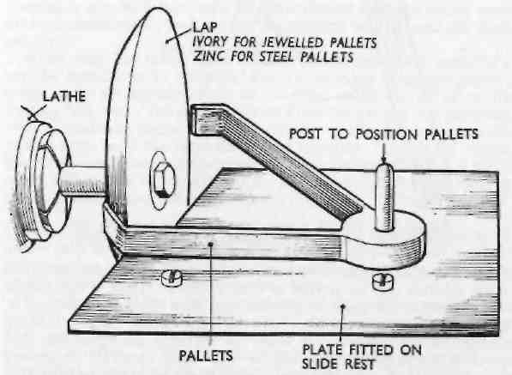
Figure 36. Polishing dead-beat pallets using a lap in the lathe. The shaped back of the lap is shown polishing the inside of the pallets.
to fit in the lathe so that laps can be changed over and still run flat and true.
52
THE DEAD-BEAT ESCAPEMENT
A flat plate is fitted to the slide rest or the cross slide as it is sometimes termed, and on this plate is a post which fits the pallet-arbor hole. The pallets are placed on this plate with the hole on the post, and the lead screw is eased off so that it is inoperative. The slide rest is adjusted so that the impulse face is coincident with the face of the lap, and this face is smeared with diamantine, then the lap is set in motion. Light pressure is maintained on the pallets, both to keep them flat on the plate and also to press the pallet faces against the lap, and the slide rest is pushed backwards and forwards rapidly. Care must be taken to keep the face of the pallets on the lap and not to run off the edge, for if this does happen the lap and pallets may be ruined.
The curved locking face and the reverse curved side of the exit dropping-off edge arc polished in the same way because these curves can be followed. The inside dropping-off face of the entrance pallet and the locking face of the exit pallet are polished on the back face of the lap, which must be shaped to suit.
Diamantine is only suitable for solid steel pallets, and if the pallets are jewelled diamond powder must be used instead of diamantine. Diamond powder can now be purchased in different grades ready for mixture and use; it is mixed with oil and smeared on the lap in just the same way as diamantine. It must be emphasised that there is no connection between diamantine and diamond powder.
Fitting Pallet Stones
Jewelled pallets are made in steel in exactly the same manner as steel pallets but when they are finished the faces are slotted for about one-third and suitable stones ground to fit. The stones are fixed in position with shellac, and care must be taken to see that they are securely fixed, otherwise they may move in the process of polishing. After fixing, the stones are ground down until flush with the steel.
The grinding is carried out in the same way as the polishing, except that a grinding lap is used. This is a copper lap into which coarser diamond powder is rolled, and as such remains permanent, unlike the polishing lap, which has to be cleaned and recharged every time it is used. Water is used on the grinding lap and not oil, but although it must be kept wet, if too much water is used it will be thrown off by the lap and everything smothered with water, including the operator.
Quite a number of pallets are jewelled with agate, but the best quality are jewelled with sapphire, which never needs repolishing or renewing except when damaged by rough handling or accidents.
The 'Scape Wheel
The 'scape wheel must be light but of course of a necessary strength, and is made from good-quality hard-rolled brass.
The teeth are cut using two cutters, one to cut the front or acting side and the other the back. They can be cut by using only one cutter, but it would have to be a very well-made one. The first cutter
53

